Objectives

Seeking a dynamic Digital Marketing role where I can leverage my expertise in SEO, content strategy, and analytics to drive brand visibility and customer engagement. Committed to staying abreast of industry trends, I aim to employ innovative digital strategies that enhance online presence, optimize conversion rates, and foster meaningful customer relationships, ultimately contributing to organizational growth and success.

# Personal details

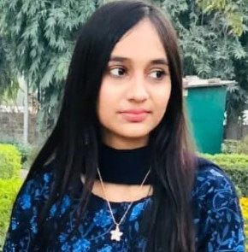**Name** Husna Saleem

**Email address** husnashahzadi@gmail.com

**Phone number** 0328-4512991

**Address** Chandraye road house#14b chunghi Amar Sidhu

# Experience

* **Aug 2021 - Sep 2022**
  + - * + Managed SEO campaigns, achieving a 30% increase in organic traffic.
        + Developed and executed content strategies, boosting engagement rates by 25%.
        + Analyzed data using tools like Google Analytics, informing campaign adjustments that led to a 20% rise in conversions.
        + Oversaw PPC campaigns with a focus on cost-efficiency, resulting in a 15% reduction in CPC.
        + Orchestrated social media initiatives, growing follower base by 50% within six months.

Top of Form

Education

Sep 2022 - Sep 2024 Associate Degree In Computer Science[ADP(CS)]

Superior University, Lahore

Learn Programming Languages C++ Learn OOP

Learn HTML5 & CSS & JAVASCRIPT

Jan 2019 - Jan 2021 Intermediate

Superior College, Lahore

Intermediate in Computer Science(I.C.S)

Jan 2018 - Jan 2019 Matric

Allied School

# 

# Skills

* **SEO Optimization**
* **Content Strategy**
* **Analytics & Data Interpretation**
* **PPC Advertising**
* **Social Media Management**

# 

# Languages

**English** Fluent

**Urdu** Fluent

# Hobbies

Tiktoker Instagramer Cooking Reading Books

# References

References available upon request.